WEekly BI Reporting
The Providence leadership team review the reported progress of the Migration Factory each Friday afternoon. The 10M Delivery Director provides a status report and includes verified numbers on the current and next iteration, to the leadership team.
The weekly status reports can be found in the INTERNAL-Providence Teams channel > Files > Status Reports.
The link to the Migration Factory Executive Overview Power BI report can be found here. The reports that contain the data that is reported on are: Current Month App Migration Status, and Next Month App Migration Status.
Data to include on the status report
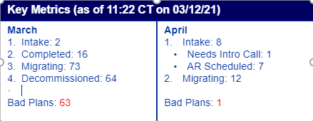
The report should be run on Friday mornings to capture the most up-to-date data. The current month numbers should include the total number of app instances on the intake board (goal should be zero), applications completed (L&S, SaaS, Hybrid), applications in the process of being migrated, applications that were migrated and had those servers decommissioned, and the number of applications that were assigned for the current iteration but were moved to constrained due to poor planning by the client.
The following month will show less information but will still show intake broken down by the columns the applications are sitting in and the number of applications that are in-progress.
Whenever you mark down the data on the status report, always include the time and day you accessed the BI report.
Verifying BI data on the status report
There are a few different queries that should be run in Providence Azure Dev Ops to verify the numbers pulled on the Power BI report.
Intake
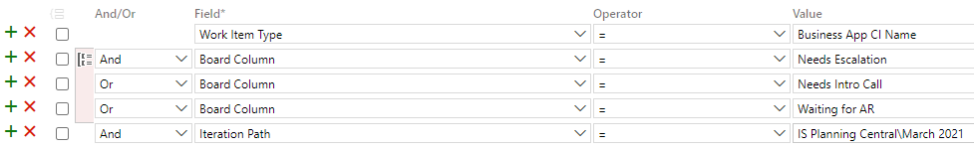
This query pulls all the cards on the intake board, current iteration.
Completed
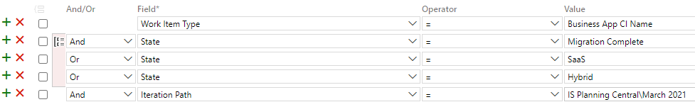
This query pulls all the in-progress work from the lift and shift, refactor, and SaaS ADO boards. Though the 10M team is not responsible for SaaS and Refactor, we are to capture and report those numbers.
Migrating
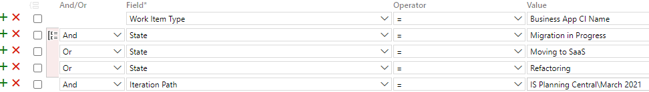
This query pulls all the completed work from the lift and shift, refactor, and SaaS ADO boards.
Decom
This query is the same as the completed query, except the value is changed to the month you are reporting on. Any application assigned to a 10M resources in results will need to be verified on the Decom Spreadsheet.

